**Analysis of AI Startup Impact on US Labor Economy via Task Automation**

Results: [1683 AI Startups Founded post launch of chatGPT in United States: Document with Task & Occupation Automation Rankings](https://docs.google.com/document/d/1fJSRzjY12HYyGxJHrjlYOxitG6mIJujq5p4MLDCqvvg/edit)

GitHub: <https://github.com/Julia-Susser/startup-gov-ai-research>

***Step 1: Data Collection***

I gathered data on startups founded post-11/30/2022 from Crunchbase, focusing on 2,196 U.S.-based startups associated with the keyword “AI.” The extracted fields include organization name, full description, industries, headquarters location, founded date, and description. The dataset includes 2,196 startups that are based in the US and have keyword “ai.”

*Query:* [Crunchbase Filters](https://www.crunchbase.com/discover/organization.companies/08922dcd9ba5f0e732b8b1b0bca57f8f)

*Datafields:* ["organization name","full_description", "industries","headquarters location","founded date","description”]

***Step 2: Task Decomposition Using Gemini***

For each startup, I used Gemini to decompose the company's product, the relevant industries and customer segments targeted before asking Gemini to give a specific example of a person using the product and the job being automated.

At each stage of prompting, Gemini produces confidence intervals to reflect certainty levels of its response. However, Gemini only gives itself confidence intervals from 6-10, which skew high. I found that when Gemini can not find information about the startup even through scraping the website link provided, Gemini will say that in its response; thus, the response will not match proper formatting and will be filtered out of the dataset.

*Prompting:*

1. Prompt 1: Extract a detailed description of the product utilizing Crunchbase description & company website.

*Your role is to describe $company ($website)'s product.*

1. Prompt 2: Generate the industry, customers, tasks/jobs the startup is automating

*Your role is to describe what jobs/tasks, industries, and customers that $company is targeting.*

*Company: $company*

*Wesbite: $website*

*Description: $description*

*________________________*

*Tasks/Jobs (comma separated list of 4, short):*

*Industry (1 item):*

*Customers (comma separated list):*

*________________________*

*Confidence Interval:*

*Reasoning:*

*________________________*

1. Prompt 3: Generate 3 situations when the product would be used and then give the ONET job that is being automated and the task that the ONET job is doing

*Your role is to provide 3 two-sentence examples of how the product from $company might be used. Do not mention the name of the company in the examples, and keep the descriptions broad.*

*Company:$company*

*Website: $website*

*Current Description: $description*

*$parsed_description*

*________________*

*Example 1:*

*ONET JOB automated 1:*

*ONET JOB 1:*

*Confidence Interval 1:*

*Reasoning 1:*

*________________*

*Example 2:*

*ONET JOB automated 2:*

*ONET JOB 2:*

*Confidence Interval 2:*

*Reasoning 2:*

*________________*

*Example 3:*

*ONET JOB automated 3:*

*ONET JOB 3:*

*Confidence Interval 3:*

*Reasoning 3:*

*________________*

***Example Prompting Output:***

Pika, [pika.art](http://pika.art)

*Crunchbase Description:* Pika is a startup that is developing an AI-powered platform for editing and generating films from captions and still images. The company aims to revolutionize the video creation and editing process through the integration of AI, offering a user-friendly and easily accessible tool for users.

*Generated Description:* Pika.art is an AI-powered platform that allows users to create and edit films using just captions and still images. By leveraging advanced AI algorithms, Pika simplifies the video creation process, making it accessible to a wider audience.

*Tasks/Jobs:* Video editing, Filmmaking, Storyboarding, Content creation *Industry:* Video production *Customers:* Filmmakers, Content creators, Marketers,

*parsed_description_conf_interval* 9

*parsed_description_conf_interval_reasoning* The company's website and description clearly indicate its focus on AI-powered video editing, targeting individuals and businesses involved in creating video content.

examples_llm Pika Use Cases:

*Example 1:* A content creator uses Pika to quickly turn a series of written blog posts into engaging video shorts, complete with transitions and animation, without needing any prior video editing experience.

*ONET JOB automated 1:* Video Editors that create, edit, and assemble video sequences. (Task ID: 27-3011.01)

*ONET JOB 1:* Video Editors

*Confidence Interval 1:* 9

*Reasoning 1:* Pika directly automates the creation and assembly of video sequences from captions and still images, replacing tasks traditionally performed by Video Editors.

*Example 2:* A filmmaker uses Pika to experiment with different visual styles for a short film, generating multiple variations of scenes with different camera angles and lighting effects based on a script and concept art.

*ONET JOB automated 2:* Film and Video Editors that edit and combine video footage, sound recordings, and graphics into a final product.

*ONET JOB 2:* Film and Video Editors

*Confidence Interval 2:* 8

*Reasoning 2:* Pika's ability to create multiple variations of scenes with different visual styles replaces the traditional tasks of film and video editors in manipulating and combining visual elements.

*Example 3:* A marketing team utilizes Pika to create short animated explainers for product features, using product images and concise text descriptions, minimizing the need for professional animation software or extensive design expertise.

*ONET JOB automated 3:* Multimedia Artists and Animators that create and edit animations, graphics, sound, and video.

*ONET JOB 3:* Multimedia Artists and Animators

*Confidence Interval 3:* 7

*Reasoning 3:* Pika automates the animation process by converting static images and text into animated sequences, simplifying tasks traditionally done by multimedia artists and animators.

***Step 3: Task Embedding and Onet Task Mapping***

First, I used the ONET tasks labeled as exposed by GPTS-are-GPTS paper and converted the tasks into full sentences with ONET title and task. For example, 'Sales managers that determine price schedules and discount rates.' Then, I embedded the ONET sentence; I did not lemmatize the sentence, as that made the results worse.

To maximize similarity between tasks and gemini examples, I instructed gemini to output ONET tasks with similar format to the ONET task database by giving Gemini examples in the prompt. Then, I mapped the embeddings from the ONET tasks to example tasks using cosine similarity. For each task, I kept the 3 highest ONET tasks (sentences with title & task) in terms of similarity.

After mapping the automated startup tasks to the ONET database, I filtered for tasks with similarities above 0.68 and 0.6, respectively. The resulting dataset included 6036 tasks and 1683 out of 2191 startups.

In the future, I want to work with all task statements, not just those from the GPTs are GPTs paper, as I think this approach would yield similar results and have less bias.

Contextual AI:

***These tasks were rated with 0.6809 task similarity and .760 title similarity***

*Example ONET Tasks (pre-embedding):*

'Film and Video Editors that trim film segments to specified lengths and reassemble segments in sequences that present stories with maximum effect.’'

*Example Gemini Tasks*

'A content creator uses Pika to quickly turn a series of written blog posts into engaging video shorts, complete with transitions and animation, without needing any prior video editing experience.'

*Example Output of Startup in ONET task mapping database with task similarity threshold at .68*

*Post Steps 1-3*

**************************

Organization: AI Phone, Website: www.aiphone.ai

generated_description: AI Phone is a mobile application that utilizes artificial intelligence to enhance the phone experience. Features include virtual phone numbers, live call captioning and translation, call transcriptions, and AI-generated call summaries.

Tasks/Jobs: Call transcription, Call summarization, Live call captioning, Language translation

Industry: Telecommunications

Customers: Individuals, Businesses

generated_description_conf_interval: 9

parsed_description_conf_interval: 9

_________________________

Example: A customer service representative uses AI Phone's call transcription feature to quickly create detailed notes from customer calls, improving their understanding of customer issues and ensuring accurate record-keeping.

situation_conf_interval: 8.0

situation_conf_interval_reasoning: Customer service representatives often take notes during calls. While some companies have systems for call recording, the AI Phone tool automates the creation of notes directly from the call audio.

##########################

job: Customer Service Representatives that record customer interactions, including details of customer inquiries, complaints, or orders.

onet_title: Customer Service Representatives

onet_task: Keep records of customer interactions or transactions, recording details of inquiries, complaints, or comments, as well as actions taken.

example_job_title: Customer Service Representatives

task_similarity: 0.8906533351171508

job_title_similarity: 0.9999991127537532

onet_weight: 0.16666666666666666

##########################

job: Customer Service Representatives that record customer interactions, including details of customer inquiries, complaints, or orders.

onet_title: Customer Service Representatives

onet_task: Confer with customers by telephone or in person to provide information about products or services, take or enter orders, cancel accounts, or obtain details of complaints.

example_job_title: Customer Service Representatives

task_similarity: 0.7797850170687675

job_title_similarity: 0.9999991127537532

onet_weight: 0.16666666666666666

##########################

job: Customer Service Representatives that record customer interactions, including details of customer inquiries, complaints, or orders.

onet_title: Customer Service Representatives

onet_task: Resolve customers' service or billing complaints by performing activities such as exchanging merchandise, refunding money, or adjusting bills.

example_job_title: Customer Service Representatives

task_similarity: 0.683595069087062

job_title_similarity: 0.9999991127537532

onet_weight: 0.16666666666666666

##########################

job: Customer Service Representatives that record customer interactions, including details of customer inquiries, complaints, or orders.

onet_title: Customer Service Representatives

onet_task: Keep records of customer interactions or transactions, recording details of inquiries, complaints, or comments, as well as actions taken.

example_job_title: Customer Service Representatives

task_similarity: 0.8906533351171508

job_title_similarity: 0.9999991127537532

onet_weight: 0.16666666666666666

##########################

job: Customer Service Representatives that record customer interactions, including details of customer inquiries, complaints, or orders.

onet_title: Customer Service Representatives

onet_task: Confer with customers by telephone or in person to provide information about products or services, take or enter orders, cancel accounts, or obtain details of complaints.

example_job_title: Customer Service Representatives

task_similarity: 0.7797850170687675

job_title_similarity: 0.9999991127537532

onet_weight: 0.16666666666666666

##########################

job: Customer Service Representatives that record customer interactions, including details of customer inquiries, complaints, or orders.

onet_title: Customer Service Representatives

onet_task: Resolve customers' service or billing complaints by performing activities such as exchanging merchandise, refunding money, or adjusting bills.

example_job_title: Customer Service Representatives

task_similarity: 0.683595069087062

job_title_similarity: 0.9999991127537532

onet_weight: 0.16666666666666666

***************************

***Step 4: Occupation & Task Automation Ratings***

To allocate weights to each task, I began by calculating an ***"ONET weight"*** for each mapping of startup tasks to onet task. I first determined the number of tasks for each startup that passed the similarity threshold and successfully matched an ONET task. Startups engaging in more general activities, like data analytics, typically match with multiple tasks, and thus each task they automate is assigned a lesser ONET weight. Initially, every startup is assigned a weight of 1, which is then evenly distributed among all the tasks it automates. For example, if a startup matches three tasks, each task receives an ONET weight of 0.33.

*Future Considerations for Weighting:* I want to weight startups differently in future analyses based on their development stage, funding level, or employee count to reflect their potential impact more accurately. Currently, all startups are given a weight of 1 in terms of their effect on automation.

***Task Automation Rating:***

To measure task automation for each unique task within an occupation, I grouped the data by task and occupation and then calculated the total "ONET weight" (from the previous step) for all tasks targeted by startups. To account for tasks that represent a smaller fraction of the workforce and would inherently be targeted by less startups, I normalized the automation scores by the percentage of the workforce engaged in each task. Thus, I calculated the percentage of the U.S. workforce engaged in each occupation and divided the sum of onet weights (# of startups automating the task) by the percentage of the workforce doing the task. Thus, for each increase in percentage of workforce, one more startup needs to automate the task to have task automation equal to 1. Task automation is on a scale of 0-1.

**Task Automation Calculation**: The ONET weight for each task is divided by its percentage of the workforce in the associated occupation performing task.

* logic needs to be finetuned here!!

***Occupation Automation Rating:***

The automation rating for each occupation is calculated by dividing the number of automated tasks by the total number of tasks within that occupation.

In the future, I plan to refine this approach by incorporating the importance metric for each task as provided by ONET in the task statement dataset because not all tasks are equally important to an occupation.

***Exploratory Data Analysis (EDA):***

The output of the data collection process is a table with 6K tasks that are being automated by specific startups as well as tables with ratings for each occupation’s automation likelihood and each task with the occupation's automation likelihood. To perform EDA,  I merged this task/occupation database with employment and wage data from the Bureau of Labor Statistics as well as skill, activity and education data from ONET. This allowed me to visualize in a more holistic way where automation is likely to have an impact on the US economy across geography as well as income and education levels. I also generated a [document](http://document) with a list of the key tasks and occupations most likely to be automated within each occupation group, along with the startups identified as targeting those occupations.

Since the task statement from the GPTs-are-GPTs paper is from 2023, I use historical ONET and BLS data, which I need to change in the future by either migrating the GPT-are-GPTS task statement or by using the entire task statement file from 2024.

Historical ONET Database: <https://www.onetcenter.org/db_releases.html>

ONET 2023: <https://www.onetcenter.org/dictionary/27.3/excel/>

BLS: <https://www.bls.gov/oes/tables.htm>

***Geography Graphs:***

I merged employment and wage data across the US, categorized into three segments: national, metro, and non-metro areas. This segmentation into metro and rural areas enabled me to map out regions in the US most vulnerable to automation. Using the occupation automation rating and the density of occupations per 1,000 people in each county, I calculated an automation score for each county. Below, you can see the graph displaying the automation score by county. The green is the metro counties and the orange is the rural countries. As can be seen by the graph, there is more dark green than red, so metro areas are more impacted by the shift in productivity due to AI.

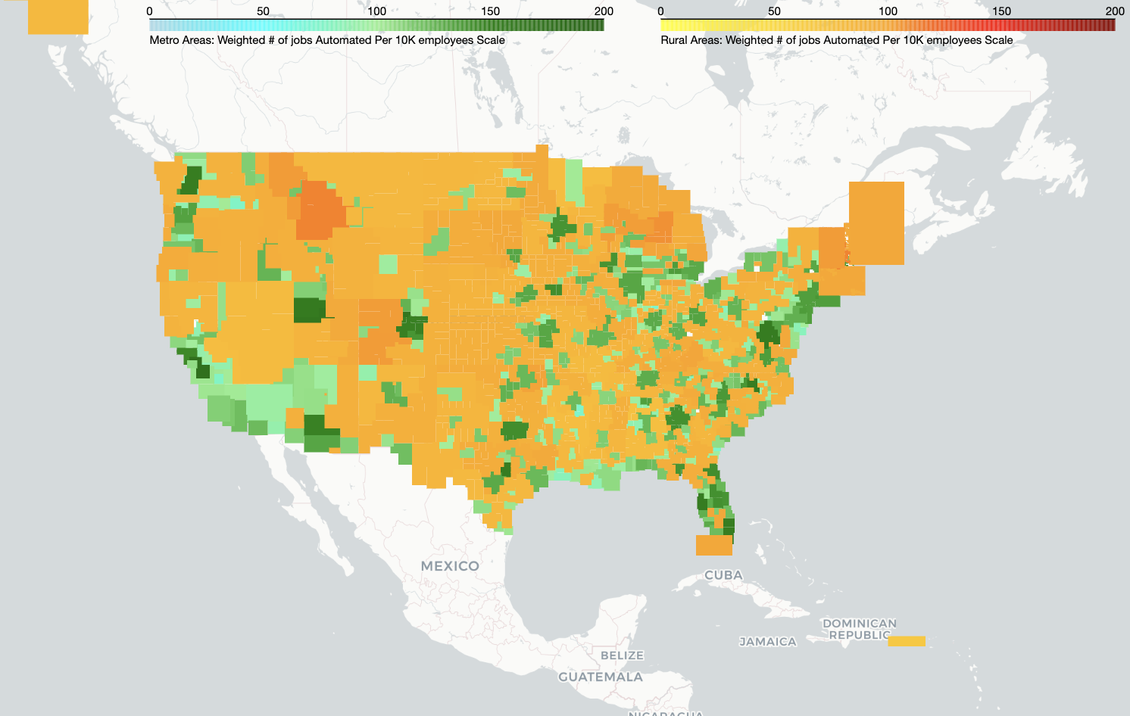

**Top 5 Rural Counties:**

'West Central-Southwest New Hampshire nonmetropolitan area',

 'Southwest Montana nonmetropolitan area',

 'Central New Hampshire nonmetropolitan area',

 'Northwest Lower Peninsula of Michigan nonmetropolitan area',

 'West Montana nonmetropolitan area',

**Top 5 Metro Counties:**

'San Jose-Sunnyvale-Santa Clara, CA',

 'Boulder, CO',

 'Provo-Orem, UT',

 'Salt Lake City, UT',

 'Washington-Arlington-Alexandria, DC-VA-MD-WV',

 'Austin-Round Rock, TX',

***Visualization of Automated Occupations Skew Towards Metro Areas***

I also tried to visualize how skewed toward metro areas the automated occupations were by finding the percentage difference in # of people performing occupation in metro versus rural areas. Indeed, each occupation on the graph has been identified as likely to be automated and the color quantifies the percentage more people in doing occupation in a METRO area. For example, the graph below reveals that Business and Financial Occupations are significantly more concentrated in metropolitan areas than in rural ones; however, office and administrative jobs being automated are more mixed between rural and metro areas.

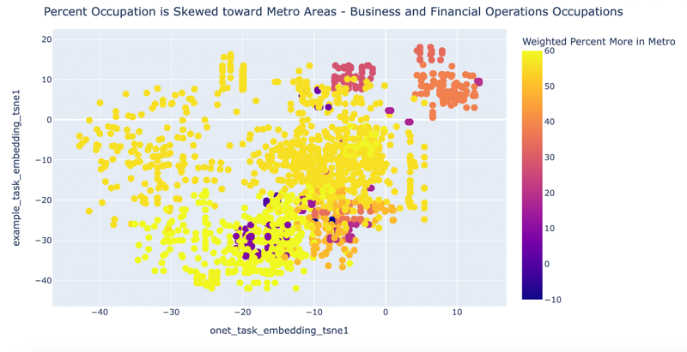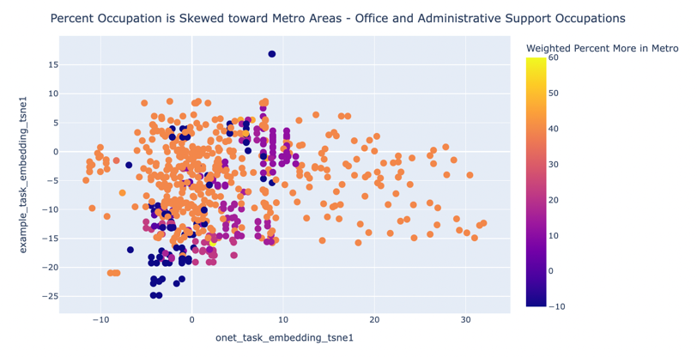

***Occupation Automation versus Metrics***

These graphs provide a visualization across all occupations where each dot represents an occupation title embedding. Each graph shows different metrics in the colors; indeed, the first graph clearly identifies the occupations that are more likely to be automated are concentrated on the left side. In the next three graphs, the occupation’s position in the graph is unchanged. Thus, the occupations on the left side that are most susceptible to automation on the left side of the graph also require extensive preparation, higher education, and offer higher wages, indicating that startups are targeting high-skill, high-preparation occupations.

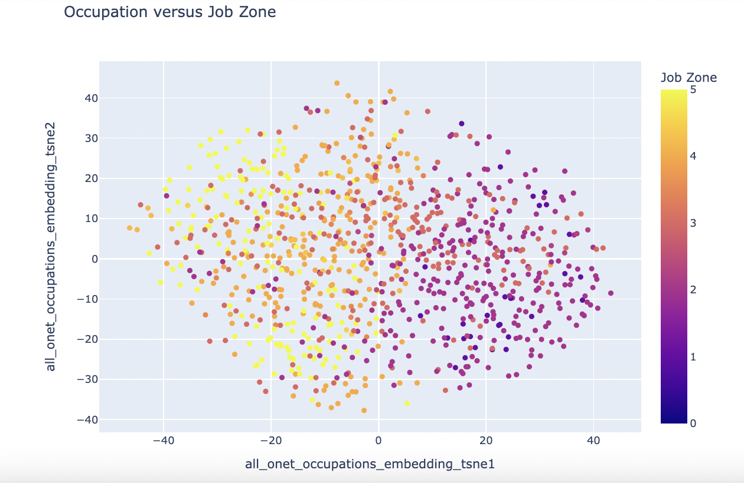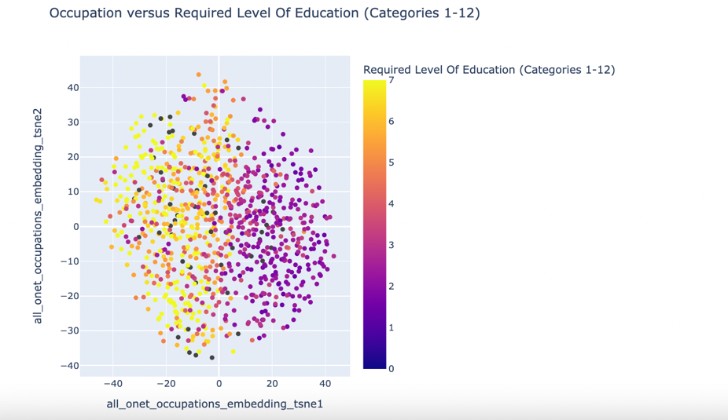

***Automation across Skills and Activities***

Next, I analyzed all tasks in the task statement database and assigned weights based on their likelihood of being automated (see above). Since each task is linked to a Distinctive Work Activity (DWA), and each DWA correlates to a specific skill, I could identify which skills startups are targeting.

The accompanying graph illustrates automation rating for skill and activity calculated by summing the task automation ratings. In this visualization, each unique pair of skill and activity is represented by a data point, where the color denotes the likelihood of automation. Note: due to the many-to-one relationship between activities and tasks, there will be a higher likelihood of automation for those activities given that I sum all of the task automation ratings (maybe should use mean instead)

This graph is particularly useful in an interactive format where users can click on the data points for specific skills and activities. The placement of each point is determined by the skill’s embedding on the y-axis and the activity’s embedding on the x-axis.

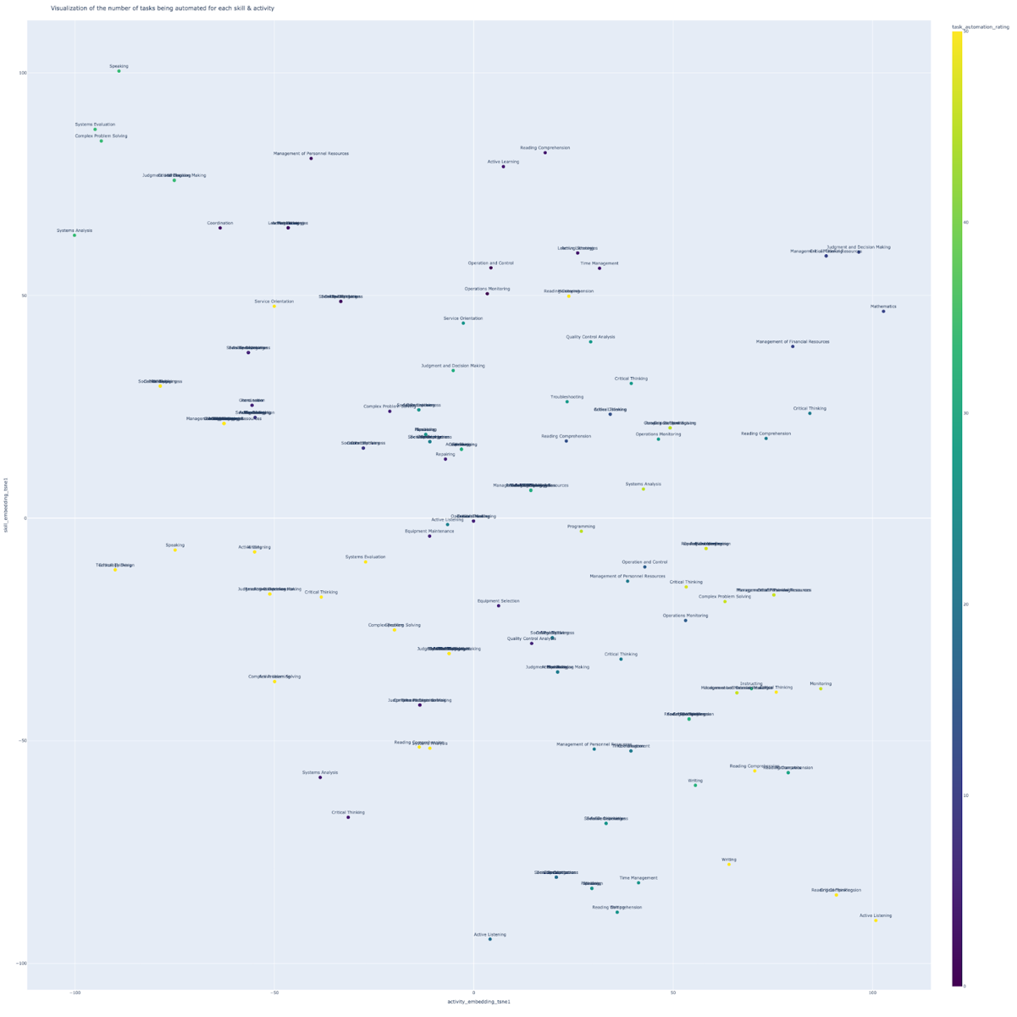

***Occupation Automation Rating***

This graph provides a quantitative breakdown of jobs automated across various income brackets by totaling the number of employed individuals nationally who are likely to be automated. For each detailed occupation, the number of people automated is calculated by multiplying the total number of people employed in the occupation times the occupation automation rating (see above). As of now, this visualization is more effectively communicated through an interactive HTML graph where you can click on the bars to see which occupation.

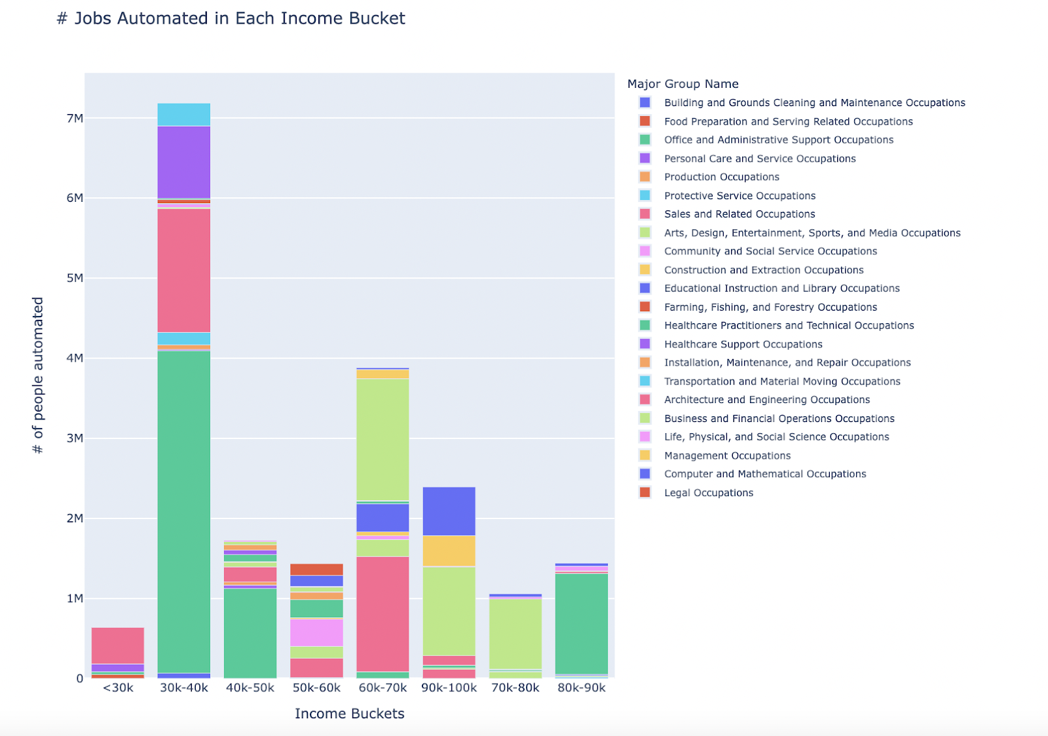

This graph also uses the occupation automation rating to highlight the percentage of individuals within each income bracket expected to face automation (total number automated in income bracket (same as first graph) divided by total employment in income bracket), as well as the percentage of occupations within these brackets that are susceptible to automation.

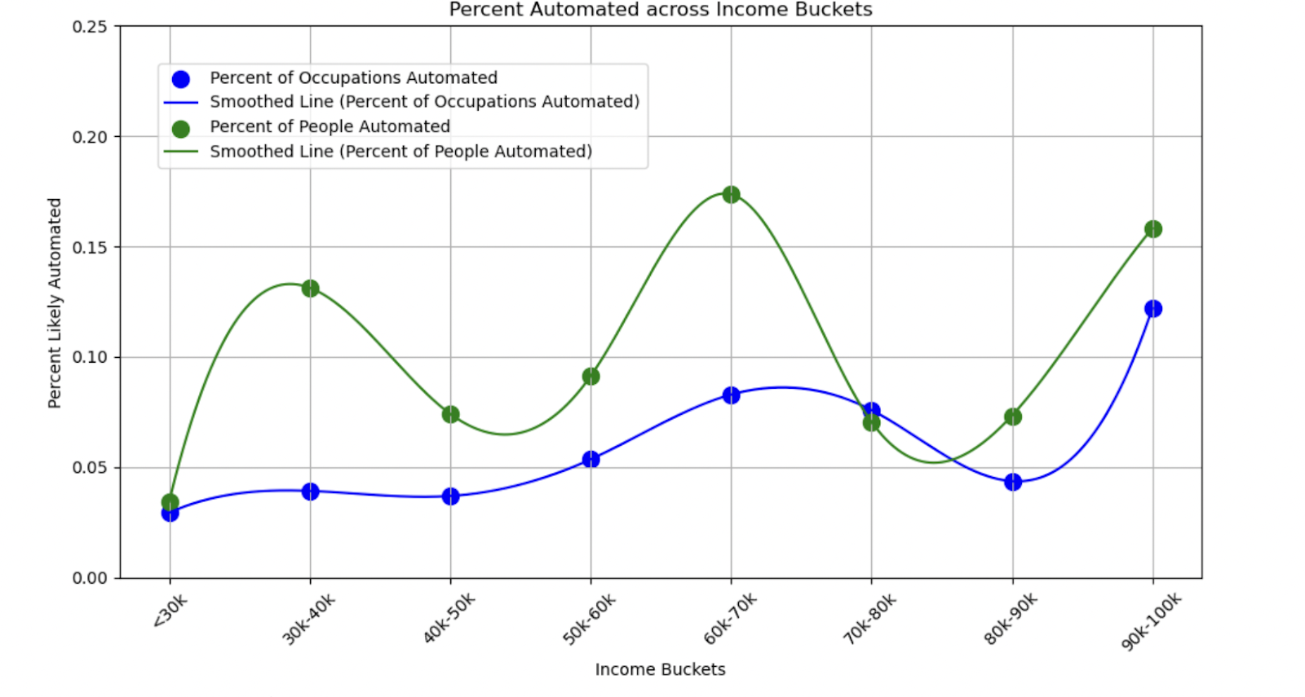

***Education and Job Zones***

I created a visualization that maps out the level of preparation required (Job Zone) for tasks likely to be automated in each occupation. In this visualization, the x-axis represents the ONET task embeddings, while the y-axis represents the task embeddings from Gemini. The color represents the Job Zone for each occupation associated with the task, which ranges from 1 (minimal preparation) to 5 (extensive preparation). The key observation is that startups are focusing on jobs and tasks that require a higher degree of preparation / higher Job Zones.

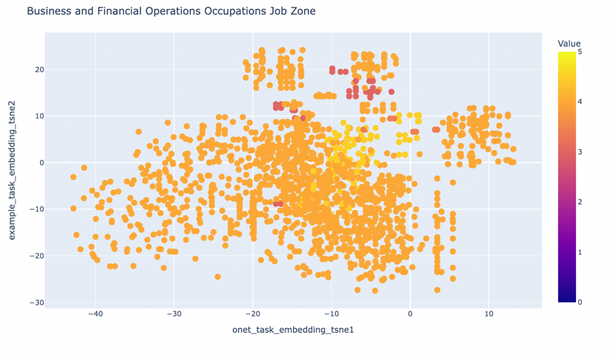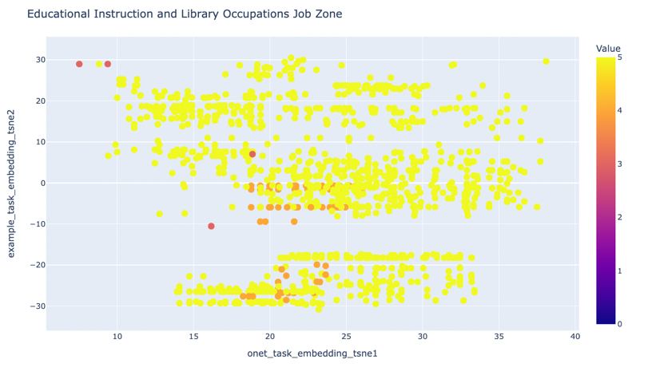

This following graph also uses the occupation automation rating to highlight the percentage of individuals across each job zone and education bracket expected to face automation (total number automated in each income bracket (same as first graph) divided by total employment in income bracket), as well as the percentage of occupations within these brackets that are susceptible to automation. The Job Zone shows peaks in zones requiring more preparation, indicating that productivity gains from automation are predominantly affecting higher-skilled workers. The education graph is highly skewed towards higher levels of education, as most occupations have lower levels of education.

